

Group Assessment Coversheet
To be attached to the front of the assessment.

Campus: Faculty: Module Code: Group: Lecturer’s Name:

Indicate | Yes | No
Plagiarism report attached

Declaration:
I declare that this assessment is my own original work except for source material explicitly acknowledged. I also declare that this assessment or any other of my original work related to it has not been previously, or is not being simultaneously, submitted for this or any other course. I am aware of the AI policy and acknowledge that I have not used any AI technology to generate or manipulate data, other than as permitted by the assessment instructions. I also declare that I am aware of the Institution’s policy and regulations on honesty in academic work as set out in the Conditions of Enrolment, and of the disciplinary guidelines applicable to breaches of such policy and regulations.

Eduvos (Pty) Ltd. (formerly Pearson Institute of Higher Education) is registered with the Department of Higher Education and Training as a private higher education institution under the Higher Education Act, 101, of 1997. Registration Certificate number: 2001/HE07/008

 |  |  | % Participated
1 | Student Full Name
 | Student Number
 | Contact Number
 | Signature
2 | Student Full Name
 | Student Number
 | Contact Number
 | Signature
3 | Student Full Name
 | Student Number
 | Contact Number
 | Signature
4 | Student Full Name
 | Student Number
 | Contact Number
 | Signature

Lecturer’s Comments:

Marks Awarded: %
Date
Signature

Group Assignment Coversheet 2023 | V1.2 Page 2 of 2

Question 1

Question 2

2.1) Implement two VLANs: one for Testers and another for UX Developers. (10 Marks)
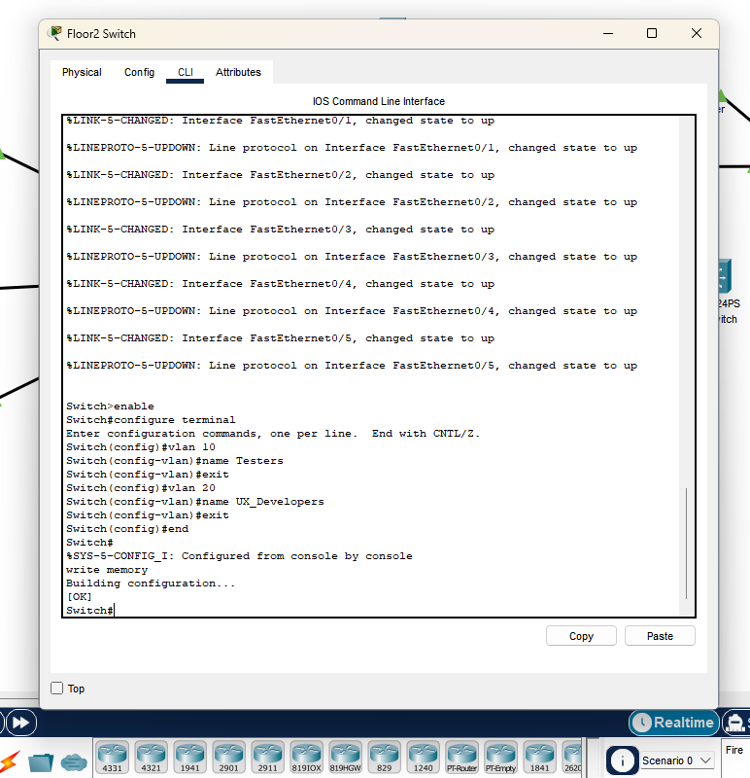

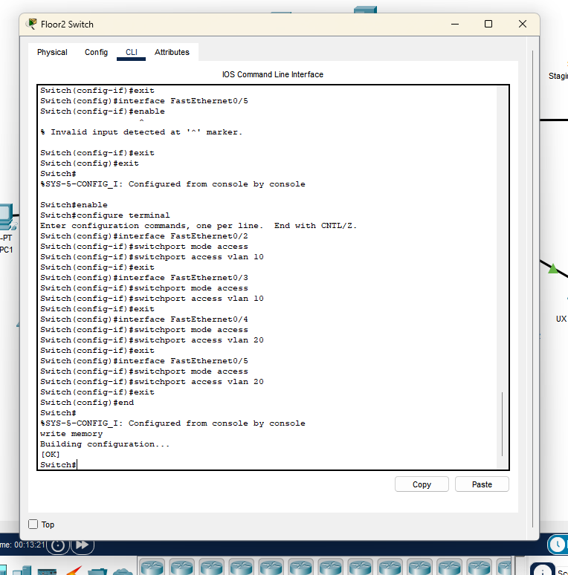

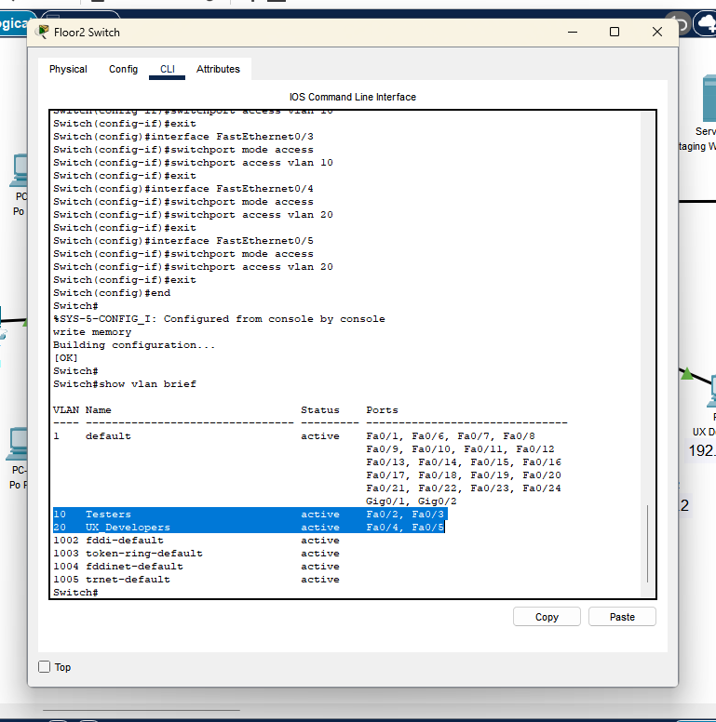

2.2) Configure the Shared Router (or a Layer 3 switch) to enable traffic between VLANs. (5 Marks)
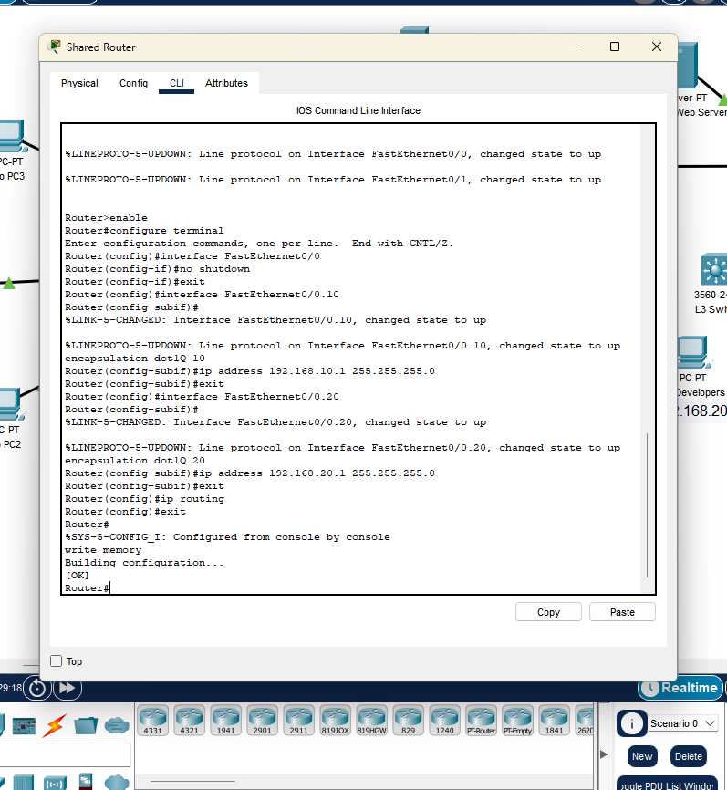

2.3) Implement an ACL (or equivalent mechanism) to block direct communication between the Testers VLAN and the UX Developers VLAN, unless explicitly required. (5 Marks)
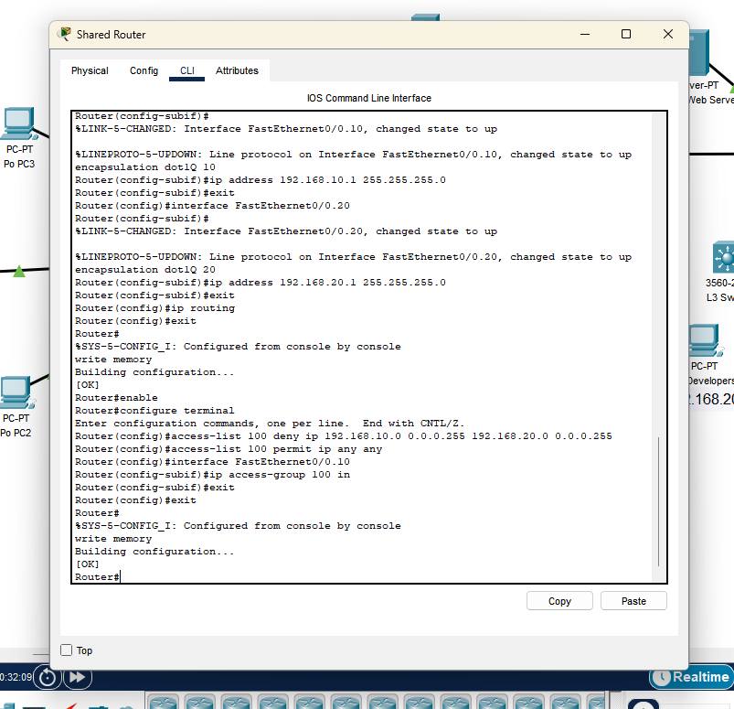

Question 3

Question 4

